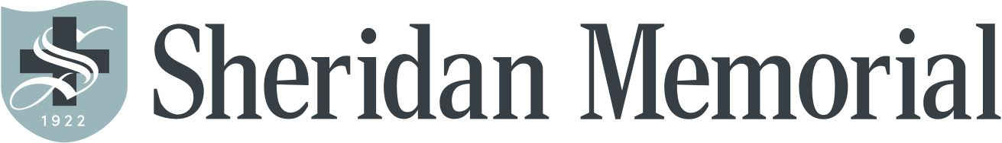

EMPLOYEE MEDICAL DISCOUNT FORM

Name of Employee:
Name of Patient:

Relation to Employee: Self Spouse Daughter Son Other

Fill blanks out completely. Incomplete forms will not be processed.
Visit Number Date of Service Beginning Balance Insurance Payment Remaining Balance
 |  | $ | $ | $
 |  | $ | $ | $
 |  | $ | $ | $
 |  | $ | $ | $
 |  | $ | $ | $

All regular full-time/part-time SMHA employees working a minimum of 20 hours per week and successfully completed their probationary period are allowed up to a twenty (20%) percent reduced fee per fiscal year for medical services provided by Sheridan Memorial Hospital Association. Listed below are the services covered:

- In-patient care
- Emergency room care
- Ancillary services
- Clinic Services

This discount is available to employees and their dependents. Dependents are defined as the
employee’s spouse as well as individuals listed on the employee’s tax return and/or individuals under the employee’s/spouse’s health insurance policy. Insurance coverage is not required.

The discount is calculated on net charges (after insurance) and is not to exceed the existing balance on the invoice for care received. A maximum of $1000.00 per employee (including dependents) will be discounted for services rendered between July 1 through June 30 of the fiscal year.
The request must be filed with the Business Office within one year of being transferred into Self Pay. Absolutely no late requests will be accepted. Incomplete forms will NOT be accepted

IT IS THE RESPONSIBLIITY OF THE EMPLOYEE TO TURN IN THEIR REQUEST.

